23rd AHE Annual CONFERENCE (Online, Zoom)

Structural Inequalities Uncovered - the Contributions of Heterodox Economics in Tackling Racial and Gender Inequality

Fridays throughout July, 2021 (2nd, 9th, 16th, 23rd and 30th)

Instructions for conference participants

The Conference will take place online on Zoom.

If you do not have Zoom already installed on your computer, you can download it here: https://zoom.us/download

More generally, you can find Zoom video tutorials here.

Each session can be accessed with a different Zoom link (see the conference webpage on the membership area for the exact details, incl. the meeting ID and passcode). We ask members to please not circulate the link.

Steps to join:
- After you click on the link to join (on the link, and you may be asked for the meeting ID/passcode), you will be taken to the main session (“hall”).

- From there, go to the Zoom menu on the bottom of the screen, where you will find the command buttons. You can access the Breakout Rooms where the parallel sessions take place (breakout room 1, 2, etc.). They work as a separate conference meeting.

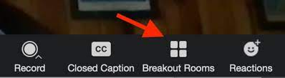

Once you click on the Breakout Rooms button, you will be able to choose the room you want to join.

A new window will pop up, and you hover over with your mouse on the room to find the button to “join”.

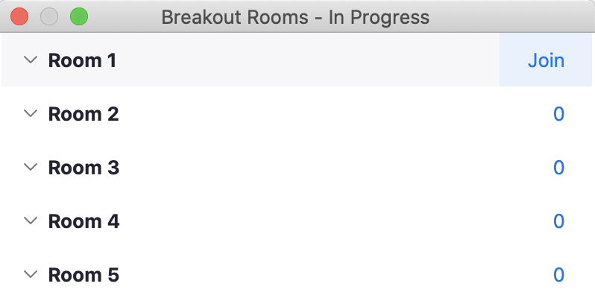

Each separate room works as a unique conference meeting.

- When you leave a Breakout Room, you return to the main session. If you forget to do so, the host will close the session and bring you back automatically to the main session (“hall”) after 60 seconds.

Main Hall
When you enter the Conference, you are brought to the Main Hall, which looks like this:
To access the five Breakout Rooms, c_l_i_c_k_ _t_h_e_ _b_u_t_t_o_n_ _“Breakout Rooms” _a_s_ _i_n_d_i_c_a_t_e_d_ _i_n_ _the picture.
Breakout Rooms
This is what you see after clicking the button:
At the end of each session, you can return to the Main Hall. If you forget to do so, the host will close the session and bring you back automatically to the Main Hall after 60 seconds.

